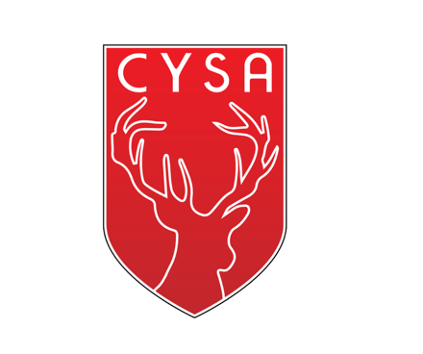

**Meeting Agenda**

**6pm, February 27th 2024**

**QYSA Boardroom & via Zoom**

**In Attendance:** Lisa Boudreau, Marc Boudreau, Justin Krueger, Ingo, Alexis, Teresa Sia

**Begin:** 6:00 pm

1. **Welcome & Acknowledgement:**

We acknowledge that we are gathered on the Traditional Territory of the Lhtako Dené.

*In Attendance:*

1. **Adoption of Agenda:**

1st/2nd Teresa Sia/Justin Krueger

1. **Meeting Minutes Approval:**

No minutes to approve this month

1. **Correspondence:**

a)None at this time

1. **Treasurer/Finances Report:**
2. Banking Update – Lisa has changed over account to new executive. Teresa Sia needs to go in and sign.
3. **Old Business:**
4. **New Business:**
5. Membership Fees – Lisa

* Will be used for putting on coaching courses, reffing classes. WL already reimburses for these courses, but if there was the capacity to do this on the district side, WL would be happy to pay a fee to district.
* Do we need the district to do this if clubs can do it themselves and just invite other clubs to join them?
* If district has a way to streamline it, then would be advantageous
* Possibly have a paid administration person in future (10hr/wk)
* How else could CYSA help clubs, competitive teams and grass roots programs?

1. Per Diem/travel costs/accommodation – Lisa

* There is currently nothing in the bylaws about per diem for travelling
* Suggest that follow CRA guidelines until we establish our own
* Per diem is needed. Do not need to travel all the time, but sometimes it is necessary. If people have to travel, they need to be compensated.
* Need written policy so it is not abused.
* Try to tie in travel with other events, such as having meetings on days where already traveling for games or training.
* MOTION: Teresa Sia: Make a motion to create a bylaw and guidelines for board approved travel, seconded by Alexis.
* BC Soccer is currently working on new policies, so we can adopt their policies once they are finished.

1. Regional Training Camp update – Marc

* At time of meeting, 27 athletes registered
* Struggling with low girl numbers as of yet
* Most of registrants are from Quesnel, WL has 4, 100 Mile has 3
* After a certain deadline date (yet to be determined) will open up registration to areas outside of the Cariboo.
* Marc will make a deadline date for registration
* Topics – will be classroom session with possibly physiotherapist to talk about taking care of your body, setting athletic mind set
* Still looking for coaches, assistants and chaperones

1. CYSA high performance teams update – Marc

* There is a call out for U14-15 boys to create a rep team
* Opportunities for anyone to take on other ages and divisions
* Discussing rep league starting in May (when regular spring league begins for most clubs)
* Set forth a tentative games schedule that does not conflict with other tournaments already scheduled

1. Zoom Fees

* Lisa has purchased a Zoom subscription, would like to be reimbursed
* Majority of meetings will be held over Zoom as it will be most practical

1. Website Fees

* Lisa has created a simple website that links to the Quesnel, Williams Lake and 100 Mile local club websites
* It says what the District is about
* District gives kids the opportunity to compete in Provincials by allowing a larger pool kids from which to create teams
* Players must be registered with their local club to be a part of the District team

1. **Other:**

**Adjourn: 6:50 pm**

**Next Meeting: Special Meeting April 30th 6pm via zoom**